Design section 1: Basic User Interface Design
This section will focus on the overall design decisions in each section, while the details into the features will be done separately.
  - Before uploading replays
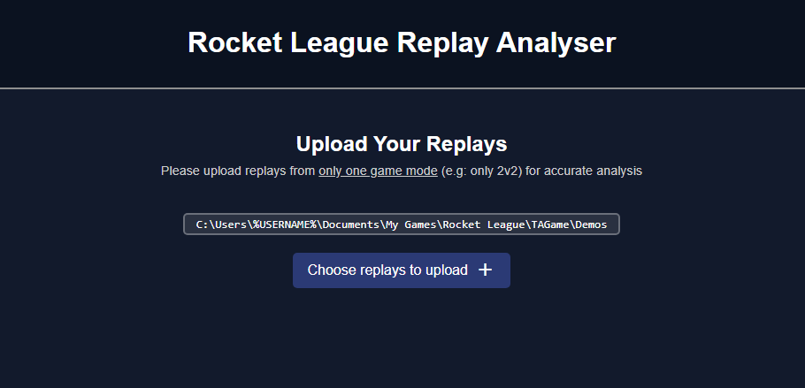
In compliance with Requirement 2.1.2, when the user initially opens the website, they are welcomed with only the initial section of the project: the Replay Upload section. This ensures the user will not be overwhelmed with information and can intuitively understand what they need to do.
Note that there is sufficient spacing between each piece of information on the screen, as well as on the sides of the website, as required by Requirement 2.1.8. This helps guide the user’s attention (clarity) as well as keeping a clean, professional aesthetic.
The reason for the space on each side of the content is to help focus the information on one area of the screen. This is done by ensuring a max-width:1200px of the content, meaning this remains consistent so long as the screen width is greater than 1200px, and remains functional by resizing otherwise.
The choice of a dark blue colour scheme is based on the general preference of a dark theme by most video game players (evidenced by platforms such as Discord using dark grey), while also including a blue theme commonly associated with Rocket League. Dark colour schemes are generally preferred because they reduce eye strain during extended use and use in dark environments.
Also note the contrasting colours between the background and the text, which enhances readability and ensures accessibility, and meets Requirement 2.1.4.
  - After uploading replays, before submitting
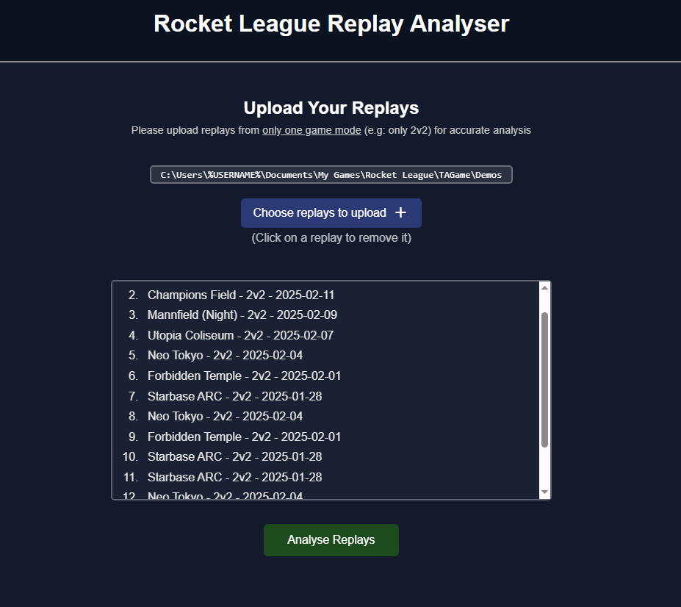
Once at least 1 replay is uploaded, the list of replays uploaded appears, including the name of the replay, the game mode, and the date, so the user can be sure they uploaded the correct ones. By putting this list in its own div, it allows me to make this list scrollable if the height surpasses some amount, to keep the amount of information on the screen concise.

